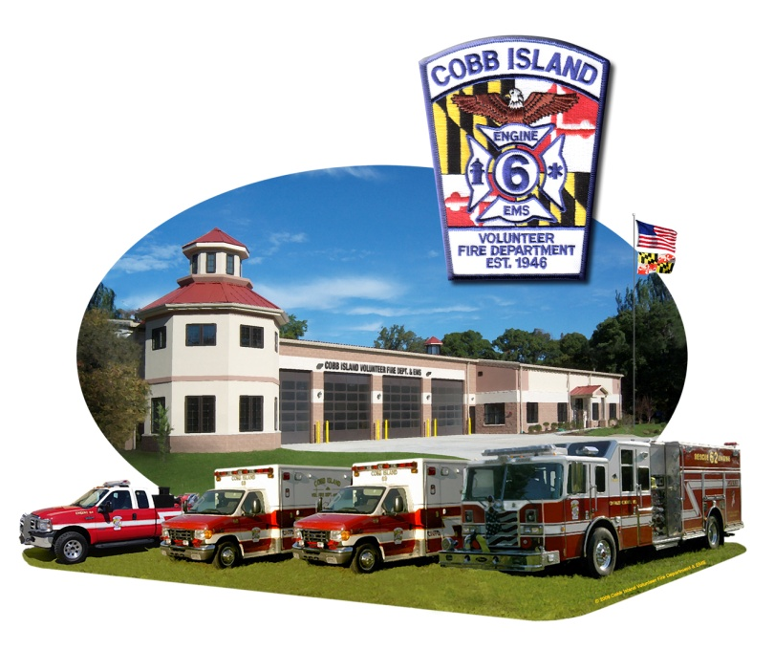
FREE FILE OF LIFE

COBB ISLAND VOL. FIRE DEPT.,
EMS & AUXILIARY
FIRE PREVENTION OPEN HOUSE
Sat.., OCT. 19, 2013

12:00 P.M. – 3:00 P.M.

Movies, Puppet Show,
Free Fire Prevention Materials,
Free Blood Pressure Checks,
Tours of Fire Apparatus.

Refreshments served.

Free Fire Truck Rides Around the Island!!!

Remember: Nov. 3, 2013 - Clocks turn back &
Change the Batteries in Your Smoke Detectors!

For information, call 301-259-2730

